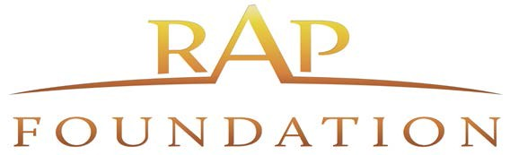

GOVERNANCE COMMITTEE Meeting Agenda

January 18, 2022 at 9:00 AM

41550 Eclectic St. Palm Desert, CA 92260
Join Zoom Meeting https://us02web.zoom.us/j/81262393959
Call- In: 1 669 900 6833 Meeting ID: 812 6239 3959
Committee Members: Chair Rudy Gutierrez, C. Borba, A. Wilson, M. Moran, E. Romero

- CALL TO ORDER

- APPROVAL OF THE AGENDA

- PUBLIC COMMENTS
Public Comments: Persons wishing to speak are requested to fill out a comment card so they may be recognized at the appropriate time. General comments regarding non-agenda items will be called for at this time. Specific comments regarding agenda items will be called for during discussion of each item. Please be prepared to limit your remarks to three (3) minutes.

- Draft Minutes of July 20, 2021 (attach 1)

Motion: Second: Yes: No: Abstentions:

- A. Nominations and election of Committee leadership:
Chair
Vice-Chair
Motion: Second: Yes: No: Abstentions:

B. Review/Update the Values for the Strategic Plan (Attach. 2)

Motion: Second: Yes: No: Abstentions:

C. Address the CEO Succession Plan for Executive Committee consideration

Motion: Second: Yes: No: Abstentions:

D. Draft a Policy to address requiring organizations to be “in good standing” in order to receive funding/services (Attach. 3)

Motion: Second: Yes: No: Abstentions:

- BOARD MEMBER/STAFF COMMENTS
Possible topic(s) for next meeting:
- Set Next Meeting Date and Time ????? ADJOURN – Schedule next meeting
Agenda Posting: Agendas will be posted on the Foundation website – www.RAPFoundation.org a minimum of 72 hours prior to the meeting date. All public record documents for matters on the open session of the Agenda are available for inspection at the meeting listed in this Agenda, and at the following location three (3) days prior to the meeting date: Regional Access Project Foundation, 41-550 Eclectic Street Palm Desert, CA 92260
If a public record document that relates to a matter on the open session of the Agenda is distributed less than 72 hours prior to the meeting date, the public record document shall be available for inspection, at the same time it is distributed, at the address listed above. Upon request, this agenda will be made available in appropriate alternative formats to persons with disabilities, as required by Section 202 of the Americans with Disabilities Act of 1990.

